Week 2

Aryan Sethi

9923103030

F2

def q1():

    print("Enter 10 names:\n")

    listnames = []

    for i in range(10):

        listnames.append(input(f"Enter {i+1}th:\t"))

    print("\n")

    for nam in listnames:

        splitted = nam.split()

        print(f"First name:\t {splitted[0]}")

        print(f"Last name:\t {splitted[-1]}\n")

    print("\nnames from 3rd to 5th\n")

    i=3

    for nam in listnames[2:5]:

        splitted = nam.split()

        print(f"{i}:")

        i+=1

        print(f"First name:\t {splitted[0]}")

        print(f"Last name:\t {splitted[-1]}\n")

    print("\nnames in reverse\n")

    i=10

    for nam in listnames[::-1]:

        splitted = nam.split()

        print(f"{i}:")

        i-=1

        print(f"First name:\t {splitted[0]}")

        print(f"Last name:\t {splitted[-1]}\n")

    print("\nnames from 8th to 5th\n")

    i=8

    for nam in listnames[7:1:-1]:

        splitted = nam.split()

        print(f"{i}:")

        i-=1

        print(f"First name:\t {splitted[0]}")

        print(f"Last name:\t {splitted[-1]}\n")

"""

a b

c d

e f

g h

i j

k l

m n

o p

q r

s t

"""

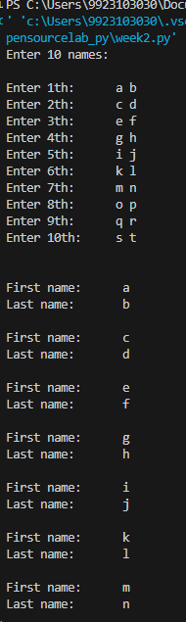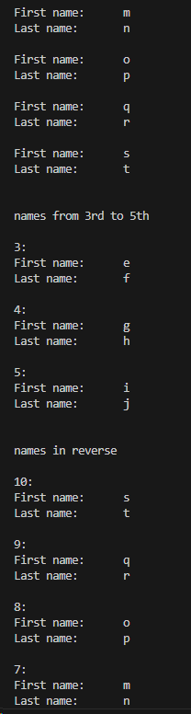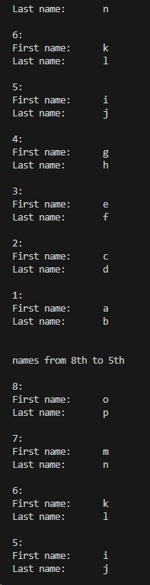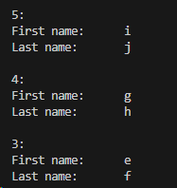

def q2():

    print("Enter 5 names:\n")

    tupname = tuple()

    print(type(tupname))

    for i in range(5):

        tupname += ( input(f"Enter {i+1}th:\t")  , )

    print("\n")

    for nam in tupname:

        splitted = nam.split()

        print(f"First name:\t {splitted[0]}")

        print(f"Last name:\t {splitted[-1]}\n")

    # try:

    #     tupname.append("first last")

    # except Exception as e:

    #     print("exceptions raised:\t")

    #     print(e)

    # print("\n\ndeleting new names to tuple")

    # try:

    #     tupname.delete("first last")

    # except Exception as e:

    #     print("exceptions raised:\t")

    #     print(e)

    print("\n\nadding new names to tuple")

    tupname += ( input(f"Enter new name:\t")  , )

    print("\n")

    for nam in tupname:

        splitted = nam.split()

        print(f"First name:\t {splitted[0]}")

        print(f"Last name:\t {splitted[-1]}\n")

    print("\n\ndeleting new name from tuple")

    na =  input(f"Enter name to del:\t")

    ind = tupname.index(na)

    tupname = tuple(list(tupname)[:ind]+list(tupname)[ind+1:])

    print("\n")

    for nam in tupname:

        splitted = nam.split()

        print(f"First name:\t {splitted[0]}")

        print(f"Last name:\t {splitted[-1]}\n")

    print("\nprinting 1st to 3rd\n")

    for nam in tupname[0:3]:

        splitted = nam.split()

        print(f"First name:\t {splitted[0]}")

        print(f"Last name:\t {splitted[-1]}\n")

    print("\nmodifying\n")

    try:

        tupname[1] = "g h"

    except Exception as e:

        print("exceptions raised:\t")

        print(e)

"""

a b

c d

e f

g h

i j

k l

a b

"""

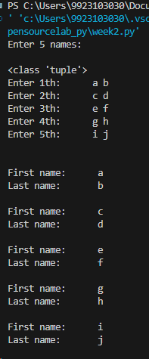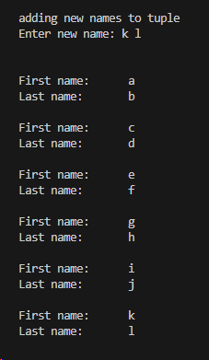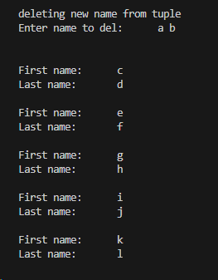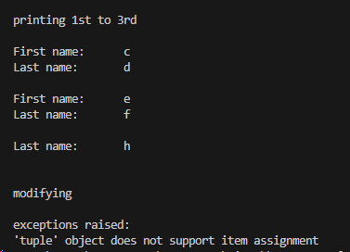

def q3():

    print("Enter names and ages:\n")

    namedict = {}

    for i in range(3):

        namedict[input("Enter name:\t")] = int(input("Enter age:\t"))

        print("\n")

    print("Priting all")

    for a,b in namedict.items():

        print(a + "\t:\t" + str(b))

    print("\n\nPriting with age >20")

    for a,b in namedict.items():

        if b>20:

            print(a + "\t:\t" + str(b))

    print("\n\nAdding jkl with age 70")

    namedict["jkl"] = 70

    print("\n\nPriting all")

    for a,b in namedict.items():

        print(a + "\t:\t" + str(b))

    print("\n\nDeleting abc")

    namedict.pop("abc")

    print("\n\nPriting all")

    for a,b in namedict.items():

        print(a + "\t:\t" + str(b))

    print("\n\nAvg age:\t")

    avg = 0

    for b in namedict.values():

        avg += b

    print( float(avg) / len(namedict))

"""

12

abc

23

def

34

ghi

"""

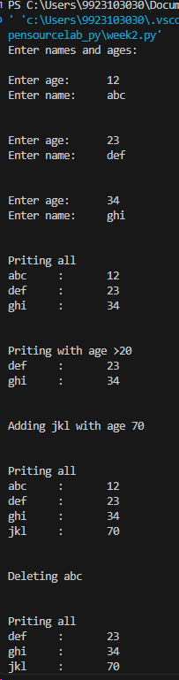

def q4():

    n = int(input("Enter number of nums:\n"))

    nums = []

    for i in range(n):

        nums.append(int(input("Enter a num:\t")))

    print("\n\n\nprinting all even nums")

    for n in nums:

        if n%2 == 0:

            print(n)

"""

10

1

2

3

4

5

6

7

8

9

10

"""

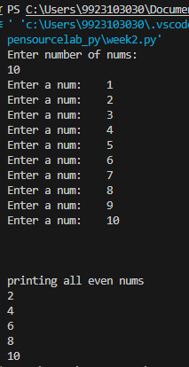

def q5():

    n = int(input("Enter number of nums:\n"))

    nums = []

    freq = {}

    for i in range(n):

        num = int(input("Enter a num:\t"))

        nums.append(num)

        if freq.get(num):

            freq[num] += 1

        else:

            freq[num] = 1

    print("\n\n\nprinting all nums")

    for n,f in freq.items():

        if f>1:

            print(n)

"""

10

1

2

3

4

4

6

7

3

4

1

"""

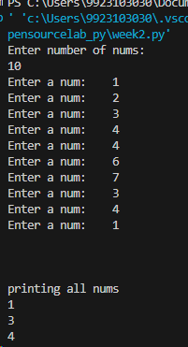

def q6():

    s = input("Enter str:\t")

    print("\nReversed str:\t")

    print(s[::-1])

def q7():

    a = 0

    b = 1

    print("fib till 5th\n")

    for i in range(5):

        print(a)

        temp = a

        a = b

        b = temp +a

def q8():

    with open("lol.txt","w") as f:

        s= "Hi, I am currently pursuing my BTech from Jaypee."

        f.write(s)

def q99():

    with open("lol1.txt","w") as f:

        for i in range(10):

            s= f"this is line {i}\n"

            f.write(s)

def q9():

    lines = []

    with open("lol1.txt","r") as f:

        lines = f.readlines()

    for l in lines[::-1]:

        print(l)

if __name__ == "__main__":

    q9()